|  |  |
| --- | --- |
| *Pacific Gas and Electric Company* | |
| Release 9.5.1 Installation Guide | |
|  |  |
|  |  |
| Project | ED AM/GIS |
|  |  |
| Prepared by | Subhankar Baidya |
| Date | 7/1/2015 |
| Version | 1.0 |
| Version Type | Draft |

|  |  |  |  |
| --- | --- | --- | --- |
| Revision History | | | |
| Document # | Date | Author | Summary of Changes |
| 1.0 | 04/16/2015 | Subhankar Baidya | Initial Document Creation |

# Introduction

## Purpose

This document is intended to detail the implementation and configuration steps required to implement Release 9.5.1 Installation Guide. This document describes the various configuration aspects required to complete any manual or automatic patch associated with this release. Each section in this document contains the steps required to patch the system in production.

## Terms Used

|  |  |
| --- | --- |
| OOTB | Out of the box. Unmodified from the commercial version. |
| TFS | Team Foundation Server |

## External Documents

Referenced are any external configuration documents or exports. These are documents that contain more detailed information about configuring a system or documents that can be loaded into an application to perform the configuration detailed in this document.

1. Customerownedidc Python script
   1. \\sfetgis-nas01\sfgispoc_data\ApplicationDevelopment\IBM_Delivery\ReleaseInstructions\9.5.1

## List of Fixes

Below is the list of change requests detailing all fixes for the data model for this release:

|  |  |
| --- | --- |
| **Item Number** | **Title** |
| [20690](http://edappgistfsprd1:8080/tfs/web/wi.aspx?pcguid=15e9a9d1-95cb-4dd0-abfe-5af14ae6201f&id=20690) | Populate SchemStreetAnno500 Data |
| [20693](http://edappgistfsprd1:8080/tfs/web/wi.aspx?pcguid=15e9a9d1-95cb-4dd0-abfe-5af14ae6201f&id=20693) | ArcFMize Schematics |
| [20709](http://edappgistfsprd1:8080/tfs/web/wi.aspx?pcguid=15e9a9d1-95cb-4dd0-abfe-5af14ae6201f&id=16538) | PAR 27206: Create Field CustomerOwnedIdc on Feature Classes (Re-apply in PRODUCTION) |
| 20744 | Data model change 9.5.1 in Pre-Prod - Configure 500 scale Schematics Anno Classes |
| 20749 | Alter Domain "District Name" change code 76 to "Coast" in Eder |
|  |  |

## Summary of Steps to Complete Patch

These are the high-level steps to complete the installation and configuration of the data model patch. Use this table as a guide for completing the installation. Links are provided that can lead either within the document for detailed explanations or to external sites such as Sharepoint.

Contents

1 Introduction 3

1.1 Purpose 3

1.2 Terms Used 3

1.3 External Documents 3

1.4 List of Fixes 3

1.5 Summary of Steps to Complete Patch 3

2 Open a Database Connection in ArcCatalog 5

3 20709: PAR 27206: Create Field CustomerOwnedIdc on Feature Classes (Re-apply in PRODUCTION) 6

4 20690 Populate SchemStreetAnno500 Data 9

5 20693 ArcFMize Schematics 10

6 20749 - Alter Domain "District Name" change code 76 to "Coast" in Eder 17

7 20744: Data model change 9.5.1 in Pre-Prod - Configure 500 scale Schematics Anno Classes 18

7.1 Create new class model names -- PGE_SCHMGRID and PGE_SCHM500ANNO 18

7.2 Create new field model names -- PGE_SCALE and PGE_FONTSIZE 20

7.3 Assign new class model names, field model names and AU 22

8 Update batch server passwords for ED006 29

9 Data Model Version Table 30

10 Known Issues 31

# Open a Database Connection in ArcCatalog

1. Open ArcCatalog.
2. Within the Catalog Tree, expand “Database Connections” and open the active connection for this process. This is the connection that is referenced in the change request associated with this document (EDGIS<DB name in the format X#Y> )

# 20709: PAR 27206: Create Field CustomerOwnedIdc on Feature Classes (Re-apply in PRODUCTION)

1. Copy the Python script from Section 1.3 titled “customerownedidc_script.py” locally.
2. Change the database connection to the desired sde file. This should be the substation database of the target environment.
3. Execute the script.
4. Open ArcCatalog and log into the target substation database as EDGIS.
5. In the SubstationDataset, right click the SUBBusBar feature class and select Properties.
6. In the Subtypes tab, select the first subtype and scroll to the CUSTOMEROWNEDIDC field in the bottom half of the window.
7. Set the domain to “SUB Yes/No Indicator”.
8. Set the default value to “N”.  
   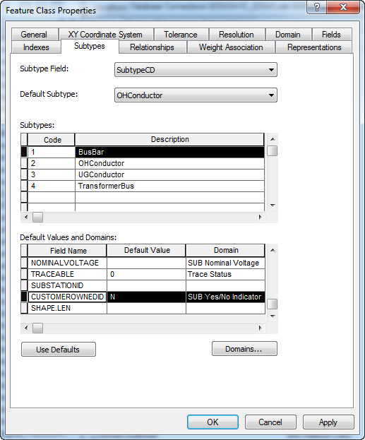
9. If no subtypes exist for the feature class, set the properties on the field in the Fields tab. This is at the feature class level rather than the subtypes level.
10. Repeat the above steps for all subtypes in the feature class.
11. Select Apply.
12. Repeat the above steps for the following feature classes:

* SUBBusBar
* SUBCapacitorBank
* SUBCurrentTransformer
* SUBExtraWinding
* SUBFuse
* SUBInterruptingDevice
* SUBLightningArrestor
* SUBLink
* SUBMtu
* SUBOHConductor
* SUBPotentialTransformer
* SUBReactor
* SUBRiser
* SUBStationBoundary
* SUBStationTransformer
* SUBSwitch
* SUBTie
* SUBTransformerBank
* SUBUGConductor
* SUBVoltageRegulator

1. Execute the following SQL after logging into the database via sqlplus as EDGIS. Attach logs to the TFS ticket titled “customerownedidc_sql_data_update.txt”.  
   update SUBBusBar set customerownedidc='N';

update SUBCapacitorBank set customerownedidc='N';

update SUBCurrentTransformer set customerownedidc='N';

update SUBExtraWinding set customerownedidc='N';

update SUBFuse set customerownedidc='N';

update SUBInterruptingDevice set customerownedidc='N';

update SUBLightningArrestor set customerownedidc='N';

update SUBLink set customerownedidc='N';

update SUBMtu set customerownedidc='N';

update SUBOHConductor set customerownedidc='N';

update SUBPotentialTransformer set customerownedidc='N';

update SUBReactor set customerownedidc='N';

update SUBRiser set customerownedidc='N';

update SUBStationBoundary set customerownedidc='N';

update SUBStationTransformer set customerownedidc='N';

update SUBSwitch set customerownedidc='N';

update SUBTie set customerownedidc='N';

update SUBTransformerBank set customerownedidc='N';

update SUBUGConductor set customerownedidc='N';

update SUBVoltageRegulator set customerownedidc='N';

commit;

# 20690 Populate SchemStreetAnno500 Data

1. Copy the SchemStreetAnno500 FGDB file locally, located here: "\\sfetgis-nas01\sfgispoc_data\ApplicationDevelopment\IBM_Delivery\ReleaseInstructions\9.5.1\schemstreet500data.gdb"
2. Attach the copied location to ArcCatalog as an external folder.
3. Connect to the target database and locate the SchemStreetAnno500 feature class in the root of the database.
4. Delete the feature class.
5. Drag and drop the SchemStreetAnno500 feature class from the FGDB into the target database. This was the folder you copied over from the shared drive to your local drive.
6. Assign privileges to the feature class:  
   SDE_EDITOR

DAT_EDITOR

DMSSTAGING

DATACONV - select only

GIS_INTERFACE - select only

GISINTERFACE - select only

SDE_VIEWER - select only

# 20693 ArcFMize Schematics

1. Ensure ArcFM is enabled on the 10.1 Desktop. Start > All Programs > ArcFM Solution > License Manager > Desktop Administrator. Verify ArcFM is set. Execute the rest of these steps from a 10.1 machine.  
   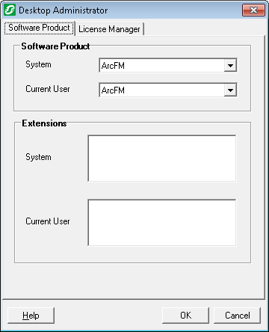
2. Open ArcCatalog
3. This step should be done in the Schematics maintenance database of the environment.
4. Connect as sde to the Schematics maintenance database.
5. Right click the connection, Create/Update ArcFM Solution System Tables  
   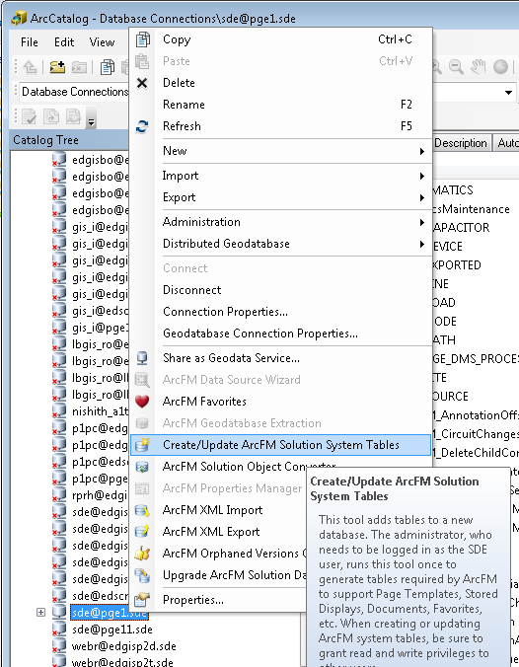
6. Click OK  
   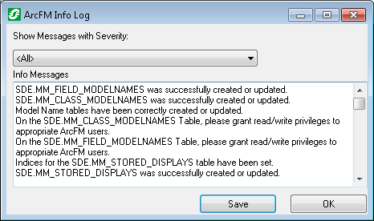
7. Right-click the connection and choose Upgrade ArcFM Solution Database  
   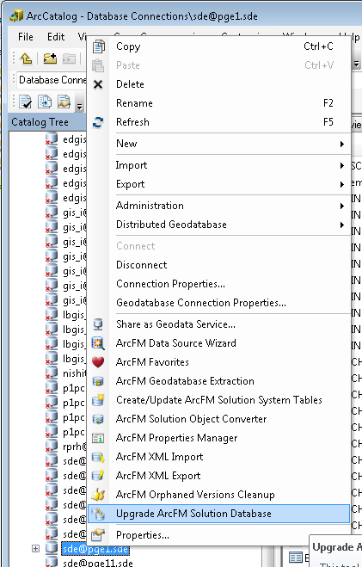
8. Click Yes for the warning.  
   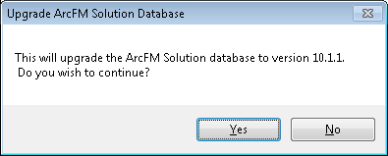
9. Click OK  
   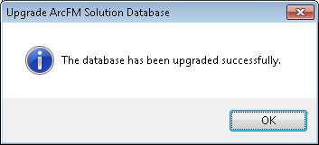
10. Copy the “geodabatase_settings_schem” files locally from the folder referenced in Section 1.3.
11. Apply the “set” file by double clicking it and accepting the prompt.
12. Right-click the connection and ArcFM XML Import  
    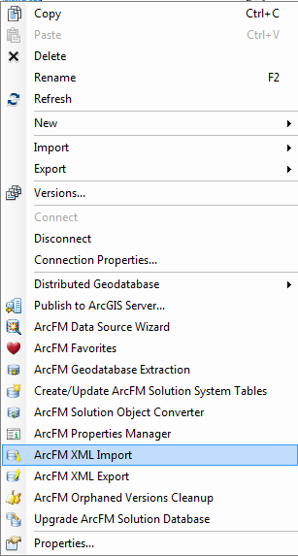
13. Navigate to the XML ("\\sfetgis-nas01\sfgispoc_data\ApplicationDevelopment\IBM_Delivery\ReleaseInstructions\9.5.1\schematics_properties.xml"), selecting Overwrite option  
    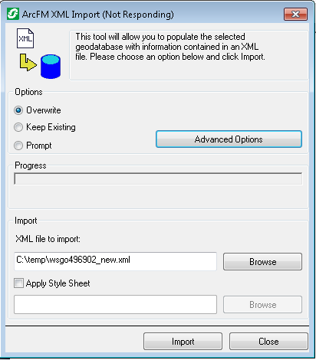
14. Click Import
15. Apply the “unset” file by double clicking it and accepting the prompt.

# 20749 - Alter Domain "District Name" change code 76 to "Coast" in Eder

A) Open ArcCatalog

B) Connect to the database as EDGIS

C) Right click on the connection and choose properties

D) Choose the Domain tab

E) In the top portion scroll down to the domain named "District Name"

F) In the bottom box change the Description to "Coast" for code 76

G) Click ok

Note: Do not copy and paste this value in as this has been proven to insert carriage returns into the Descriptions and break the data model.

# 20744: Data model change 9.5.1 in Pre-Prod - Configure 500 scale Schematics Anno Classes

## Create new class model names -- PGE_SCHMGRID and PGE_SCHM500ANNO

1. Create new class model name -- PGE_SCHMGRID under "PGE ED Object Class Model Name".
   1. Right click on the target database’s SDE file in ArcCatalog and select Properties.
   2. Select the Domains tab and scroll to the PGE ED Object Class Model Name domain.
   3. Check whether the model names are already present. If so, skip creating new model names by clicking “Cancel” button. Else follow the below steps.
   4. Scroll to the bottom of the list of codes/values at the “Coded Values” section of the screen and add PGE_SCHMGRID/ PGE_SCHMGRID to the end of the list.
   5. Click Apply button. Click OK.

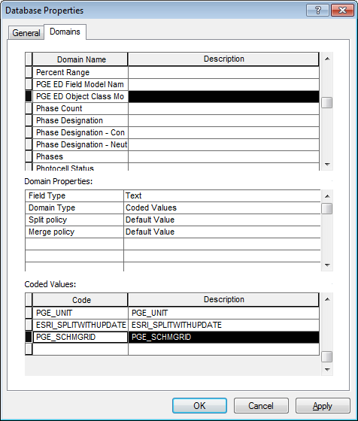

1. Create new class model name -- PGE_SCHM500ANNO under "PGE ED Object Class Model Name".
   1. Right click on the target database’s SDE file in ArcCatalog and select Properties.
   2. Select the Domains tab and scroll to the PGE ED Object Class Model Name domain.
   3. Check whether the model names are already present. If so, skip creating new model names by clicking “Cancel” button. Else follow the below steps.
   4. Scroll to the bottom of the list of codes/values at the “Coded Values” section of the screen and add PGE_SCHM500ANNO/ PGE_SCHM500ANNO to the end of the list.
   5. Click Apply button. Click OK.  
      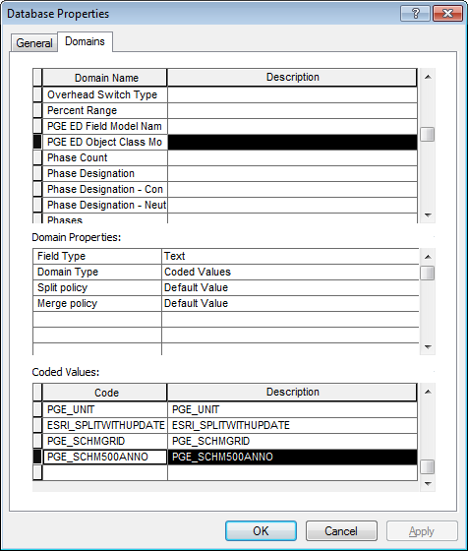

## Create new field model names -- PGE_SCALE and PGE_FONTSIZE

1. Create new field model name -- PGE_SCALE under "PGE ED Field Model Name".
   1. Right click on the target database’s SDE file in ArcCatalog and select Properties.
   2. Select the Domains tab and scroll to the PGE ED Field Model Name domain.
   3. Check whether the model names are already present. If so, skip creating new model names by clicking “Cancel” button. Else follow the below steps.
   4. Scroll to the bottom of the list of codes/values at the “Coded Values” section of the screen and add PGE_SCALE / PGE_SCALE to the end of the list.
   5. Click Apply button. Click OK.  
      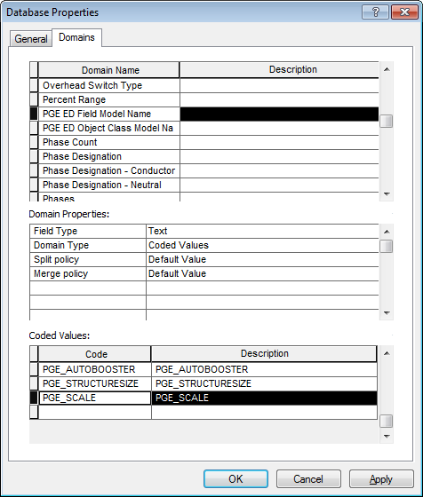
2. Create new field model name -- PGE_FONTSIZE under "PGE ED Field Model Name".
   1. Right click on the target database’s SDE file in ArcCatalog and select Properties.
   2. Select the Domains tab and scroll to the PGE ED Field Model Name domain.
   3. Scroll to the bottom of the list of codes/values at the “Coded Values” section of the screen and add PGE_FONTSIZE / PGE_FONTSIZE to the end of the list.
   4. Click Apply button. Click OK.  
      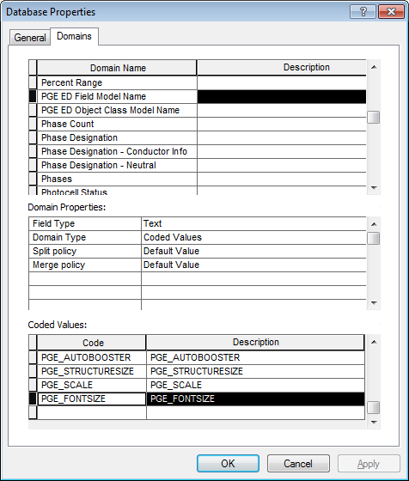

## Assign new class model names, field model names and AU

1. Assign PGE_SCHMGRID class model name to EDGIS.Schematics_Unified_Grid feature class.
   1. Expand EDGIS.CommonFeaturesDataset, right click on EDGIS.Schematics_Unified_Grid and select ArcFM Properties Manager.
   2. Select the “Model Names” tab.
   3. Ensure the **“PGE ED Object Class Model Name”** is selected in the **“Model Name Domain”** dropdown.
   4. Double click the PGE_SCHMGRID model name on the left hand side to assign it on the right side.
   5. Click Apply Button.
   6. Select the “Field Model Names” tab. Select “SCALE” field.
   7. Ensure the **“PGE ED Field Model Name”** is selected in the **“Model Name Domain”** dropdown.
   8. Double click the PGE_SCALE model name on the left hand side to assign it on the right side.
   9. Click Apply. Click OK.

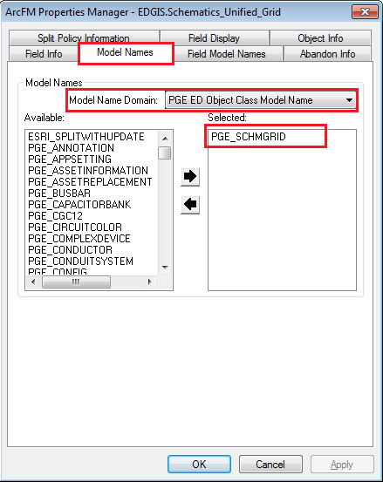

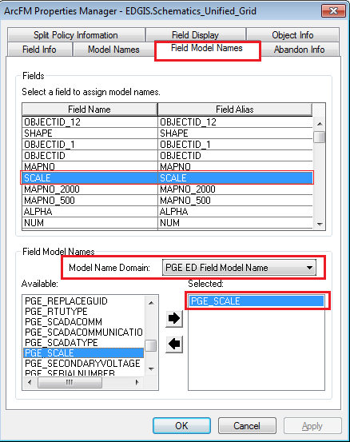

1. Assign PGE_SCHM500ANNO class model name, PGE_ FONTSIZE field model name and “PGE Annotation Half Font Size AU” autoupdater to all **Schem500Anno** feature classes in the **ElectricDataset**.

List of Schem500Anno feature classes

1. EDGIS.CapacitorBankSchem500Anno
2. EDGIS.DeviceGroupSchem500Anno
3. EDGIS.DynProtDevSchem500Anno
4. EDGIS.ElecStitchPointSchem500Anno
5. EDGIS.FaultIndicatorSchem500Anno
6. EDGIS.FuseSchem500Anno
7. EDGIS.PriGenerationSchem500Anno
8. EDGIS.StepdownSchem500Anno
9. EDGIS.SwitchSchem500Anno
10. EDGIS.TransformerSchem500Anno
11. EDGIS.VoltageRegulatorSchem500Anno
    1. In the ElectricDataset, right click on a **Schem500Anno** feature class and select ArcFM Properties Manager.
    2. Select the Model Names tab.
    3. Ensure the **“PGE ED Object Class Model Name”** is selected in the **“Model Name Domain”** dropdown.
    4. Double click the PGE_SCHM500ANNO model name on the left hand side to assign it on the right side.
    5. Click Apply Button.
    6. Select the “Field Model Names” tab. Select “FONTSIZE” field.
    7. Ensure the **“PGE ED Field Model Name”** is selected in the **“Model Name Domain”** dropdown.
    8. Double click the PGE_ FONTSIZE field model name on the left hand side to assign it on the right side.
    9. Click Apply.
    10. Select the “Object Info” tab. Select “On Feature Create” feature property.
    11. Click “Multiple” from the dropdown at the right hand side.
    12. Double click the “PGE Annotation Half Font Size AU” on the left hand side to assign it on the right side. Click OK.
    13. Click Apply. Click OK.
    14. Repeat the above steps for all **Schem500Anno** feature classes.

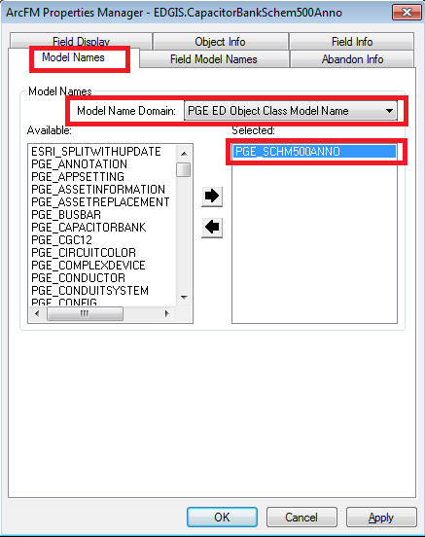

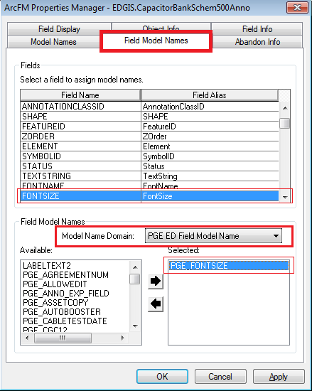

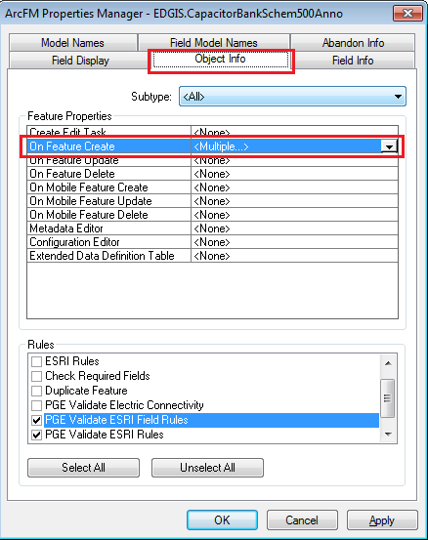

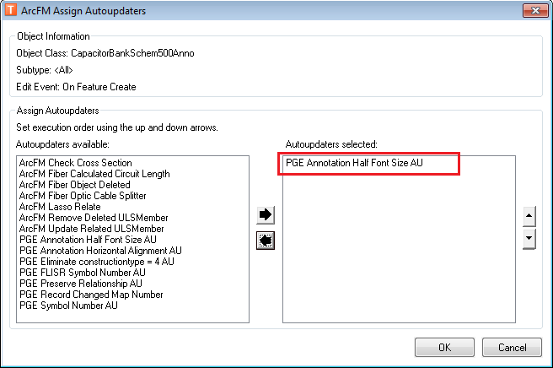

# Update batch server passwords for ED006

1. On the batch server for this environment, please navigate to the following location:

D:\Program Files (x86)\Miner and Miner\PG&E Custom Components\SAP Asset Synch

3. You should find a file named Telvent.PGE.SAP.dll.Config. Open it and change the passwords for the gis_i and pgedata users to the correct passwords for the environment.

4. Restart both the data processing and posting GDBM services on that batch server to apply the changes.

# Data Model Version Table

**Database Configuration:**

1. Open SQL Plus.
2. Log in using the same server and user as was used in section 2.  
     
   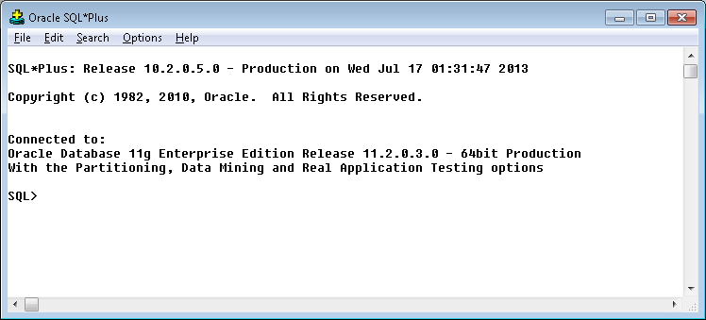
3. Run the SQL below:

update pgedatamodelversion set currentidc='N' where currentidc='Y';

insert into pgedatamodelversion (OBJECTID, CURRENTIDC, DATEAPPLIED, APPLIEDBYPERSONNAME, MODELVERSION) values (**83**,'Y',sysdate,'**<Insert person done by>**','**9.5.1 TFS Ticket #<Ticket num>**');

commit;

# Known Issues

<Please List any other issues encountered here while following the document>